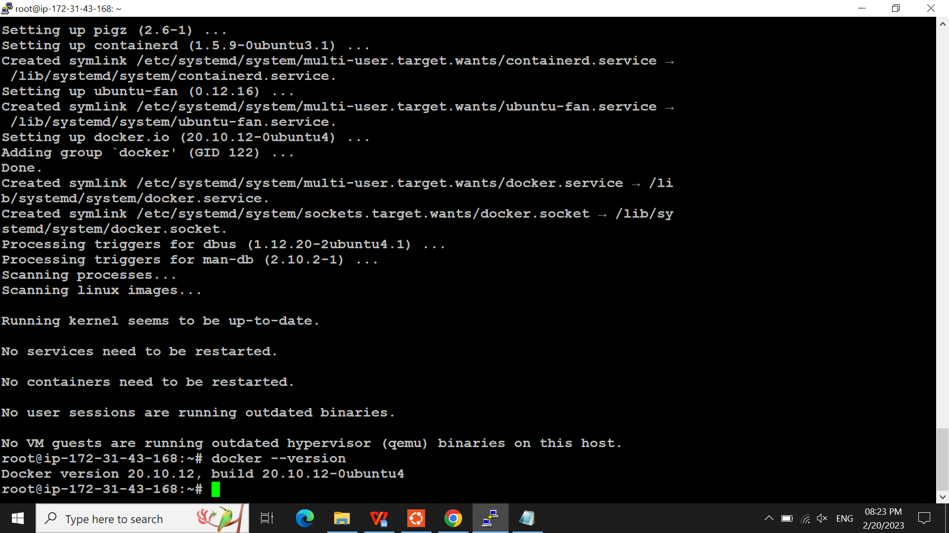

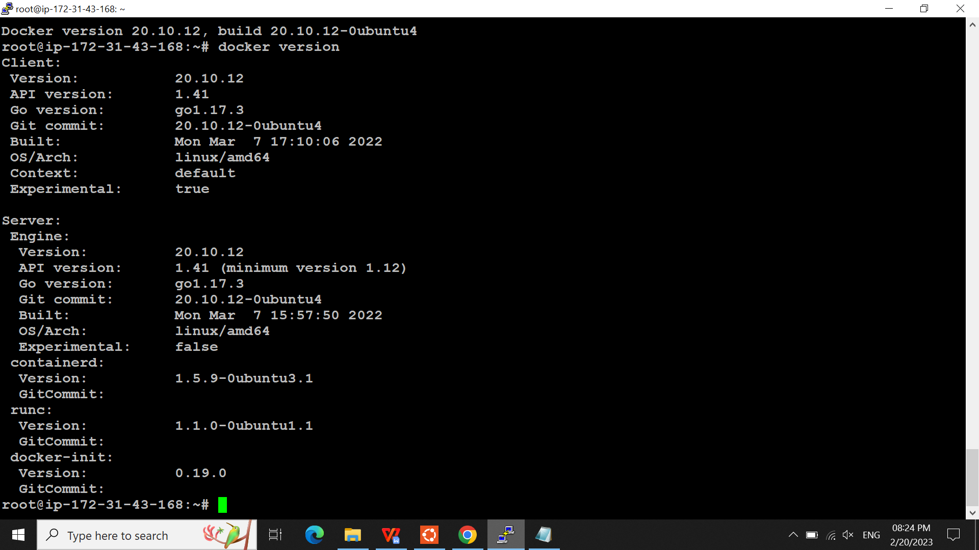

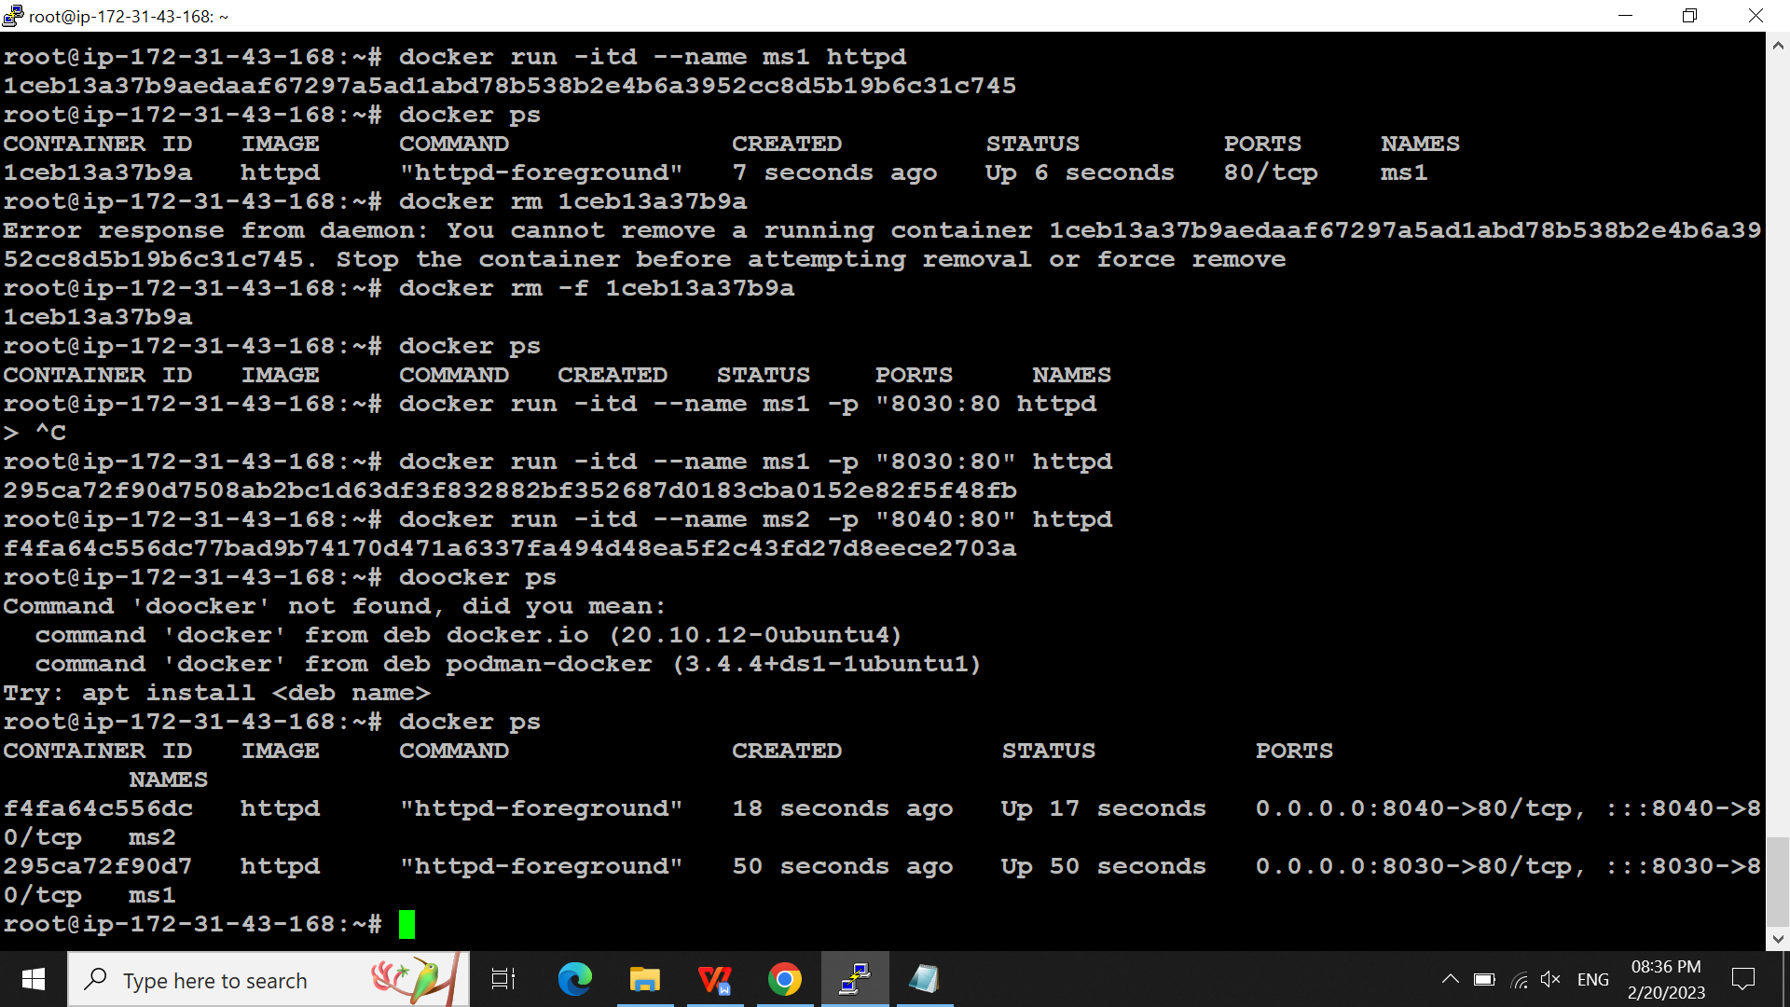

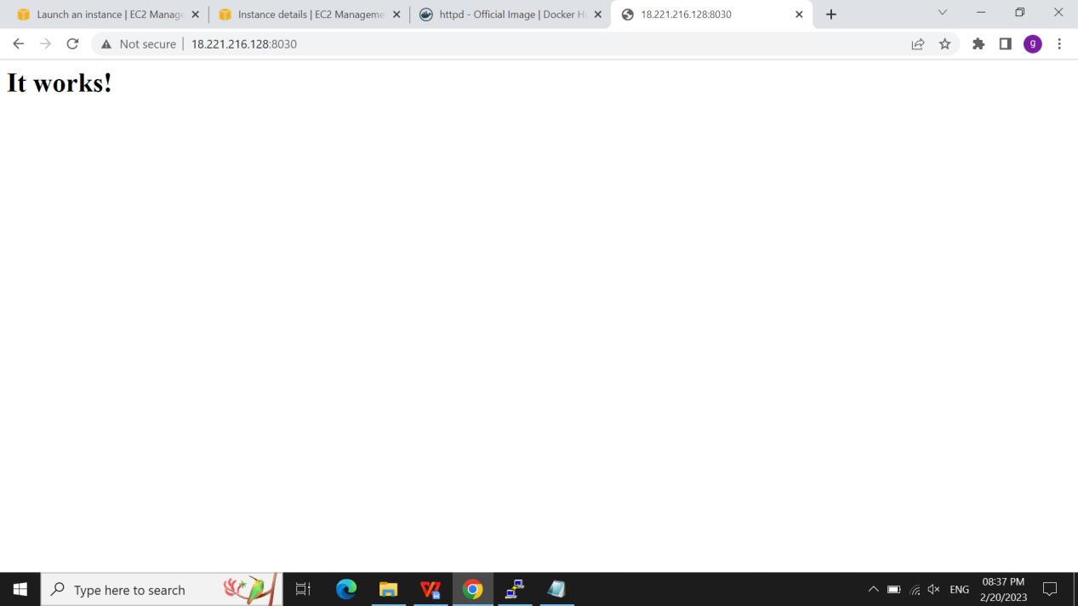

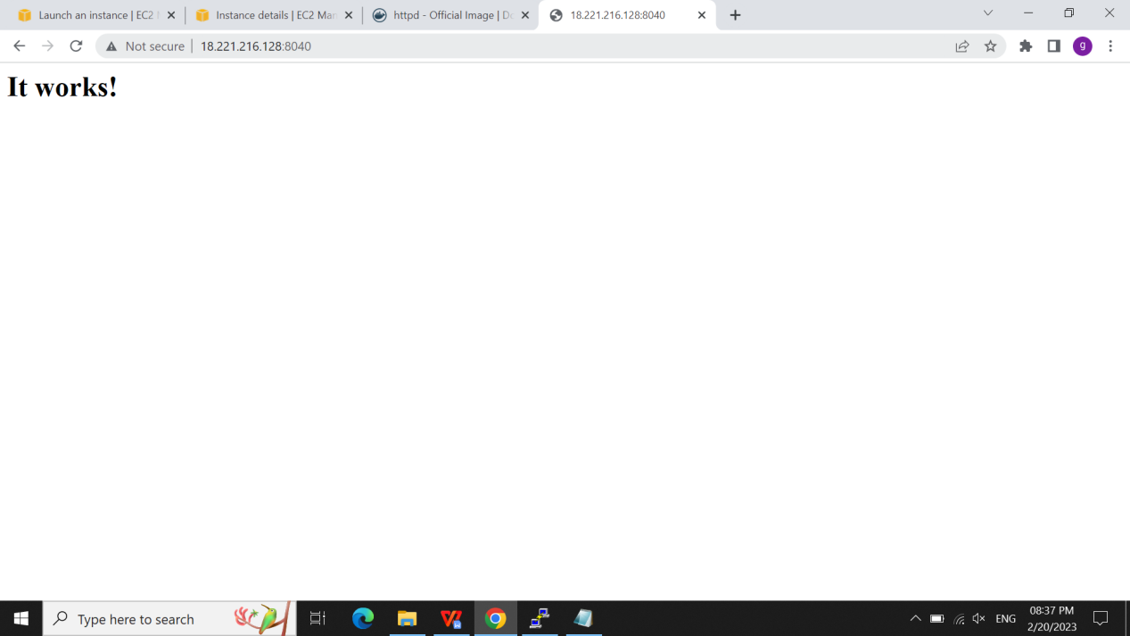

CHANGING THE SOURCE CODE OF THE CONTAINER:

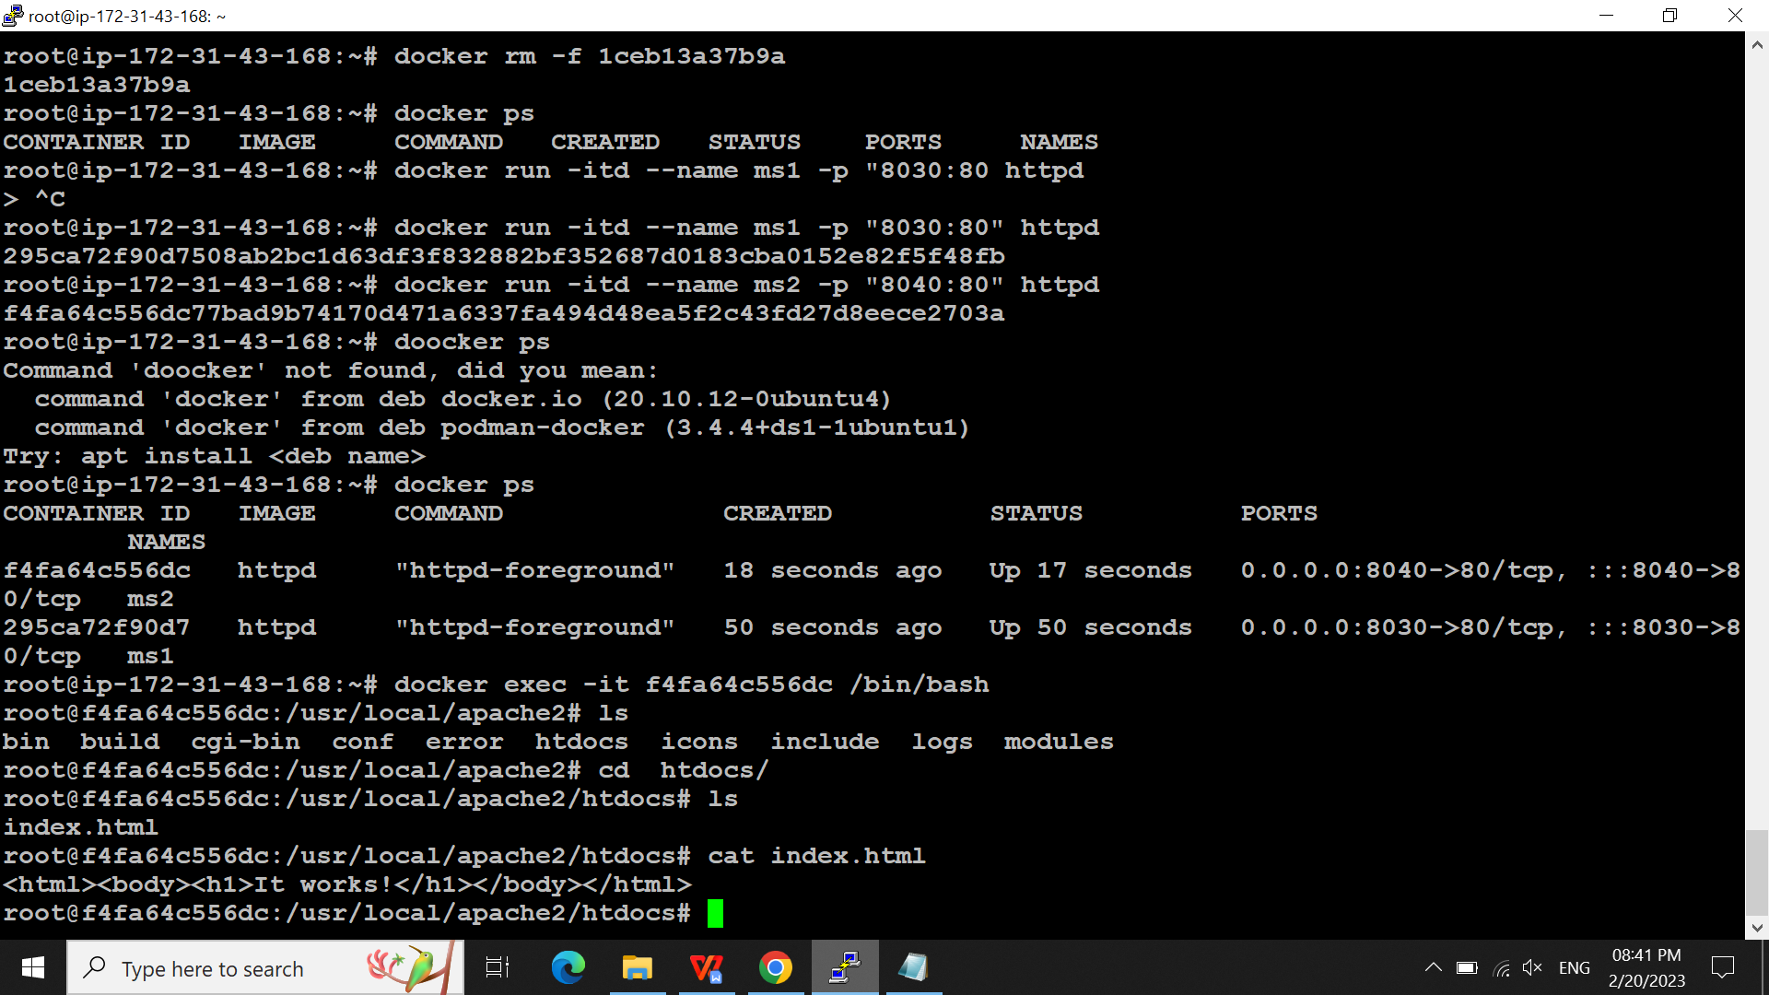

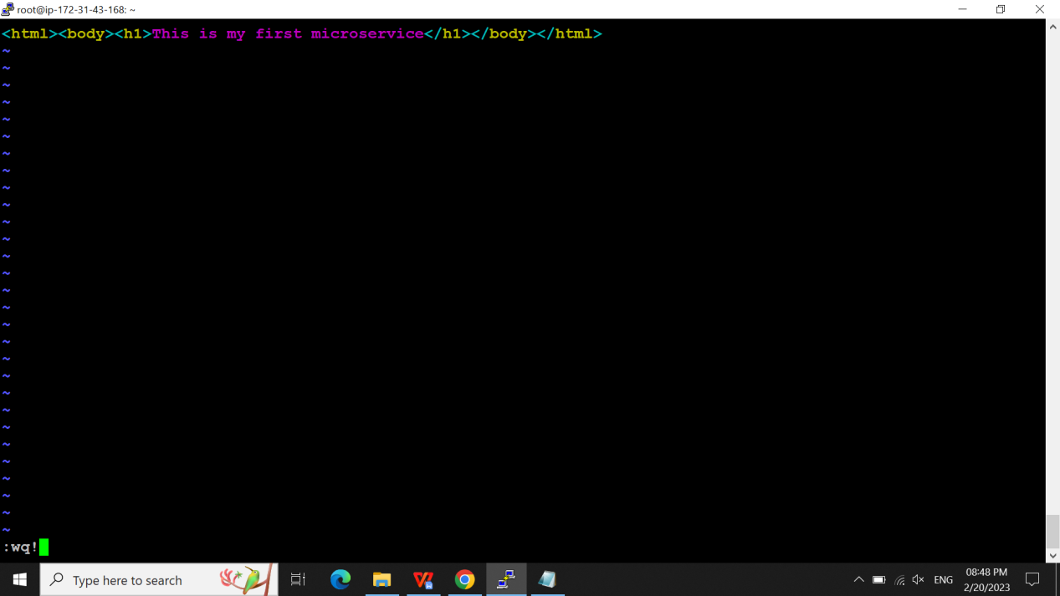

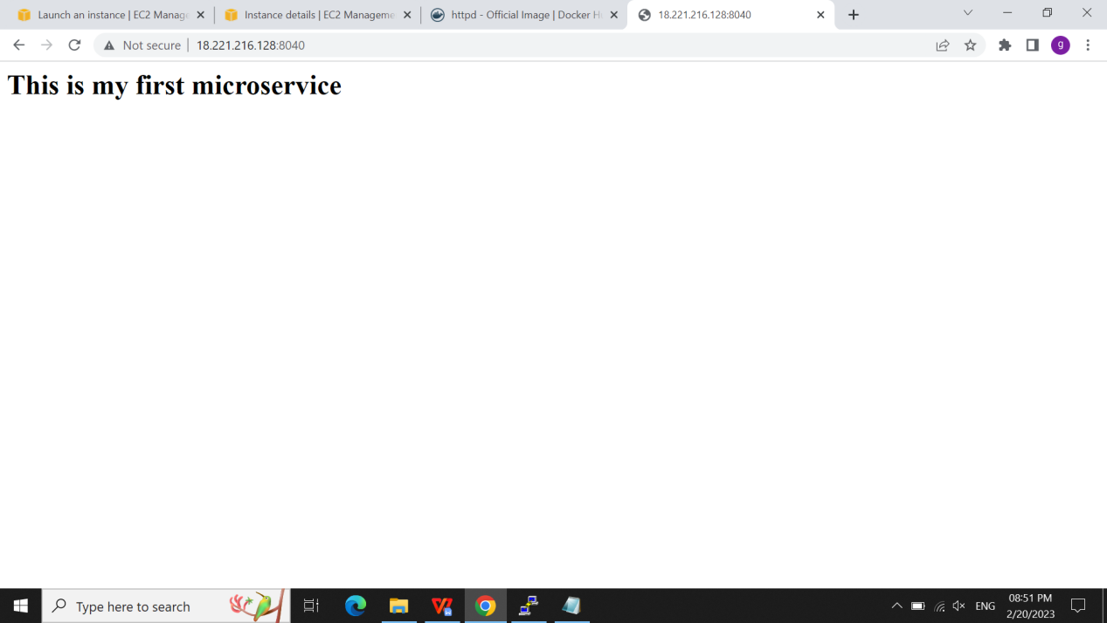

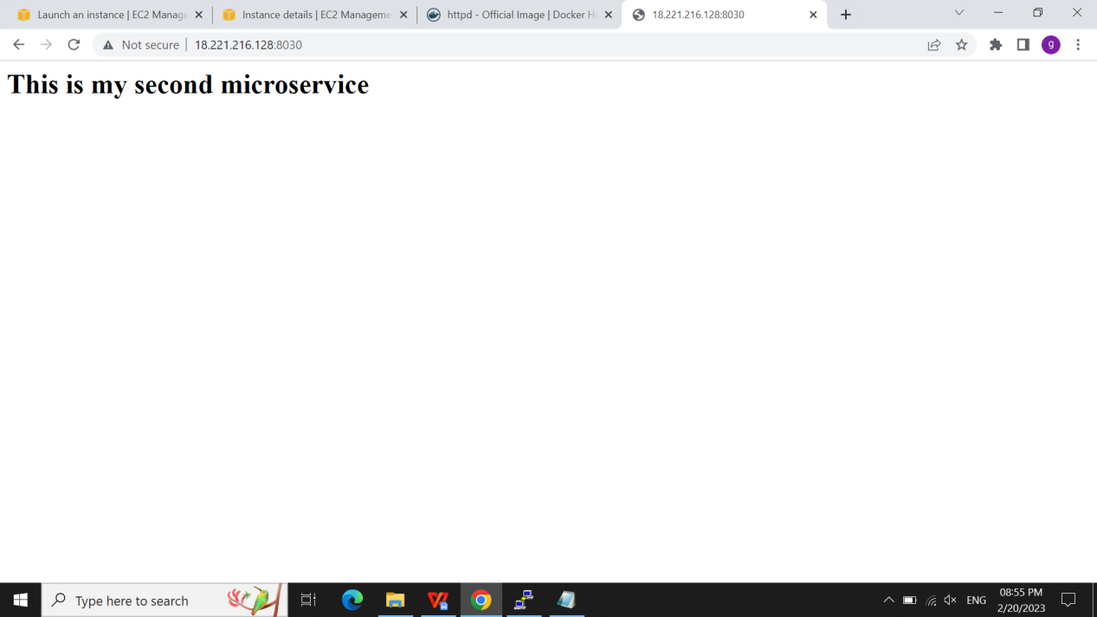

sudo apt-get install docker.io -y

2 sudo apt-get update

3 sudo apt-get instll docker.io -y

4 sudo apt-get install docker.io -y

5 docker --version

6 docker version

7 docker pull httpd

8 docker images

9 docker run -itd --name ms1 httpd

10 docker ps

11 docker rm 1ceb13a37b9a

12 docker rm -f 1ceb13a37b9a

13 docker ps

14 docker run -itd --name ms1 -p "8030:80 httpd

15 docker run -itd --name ms1 -p "8030:80" httpd

16 docker run -itd --name ms2 -p "8040:80" httpd

17 doocker ps

18 docker ps

19 docker exec -it f4fa64c556dc /bin/bash

20 ls

21 cd snap/

22 ls

23 cd ..

24 docker ps

25 docker exec -it 295ca72f90d7 /bin/bash

26 docker ps

Docker stats c-id - to view the cpu mem utiliazation.

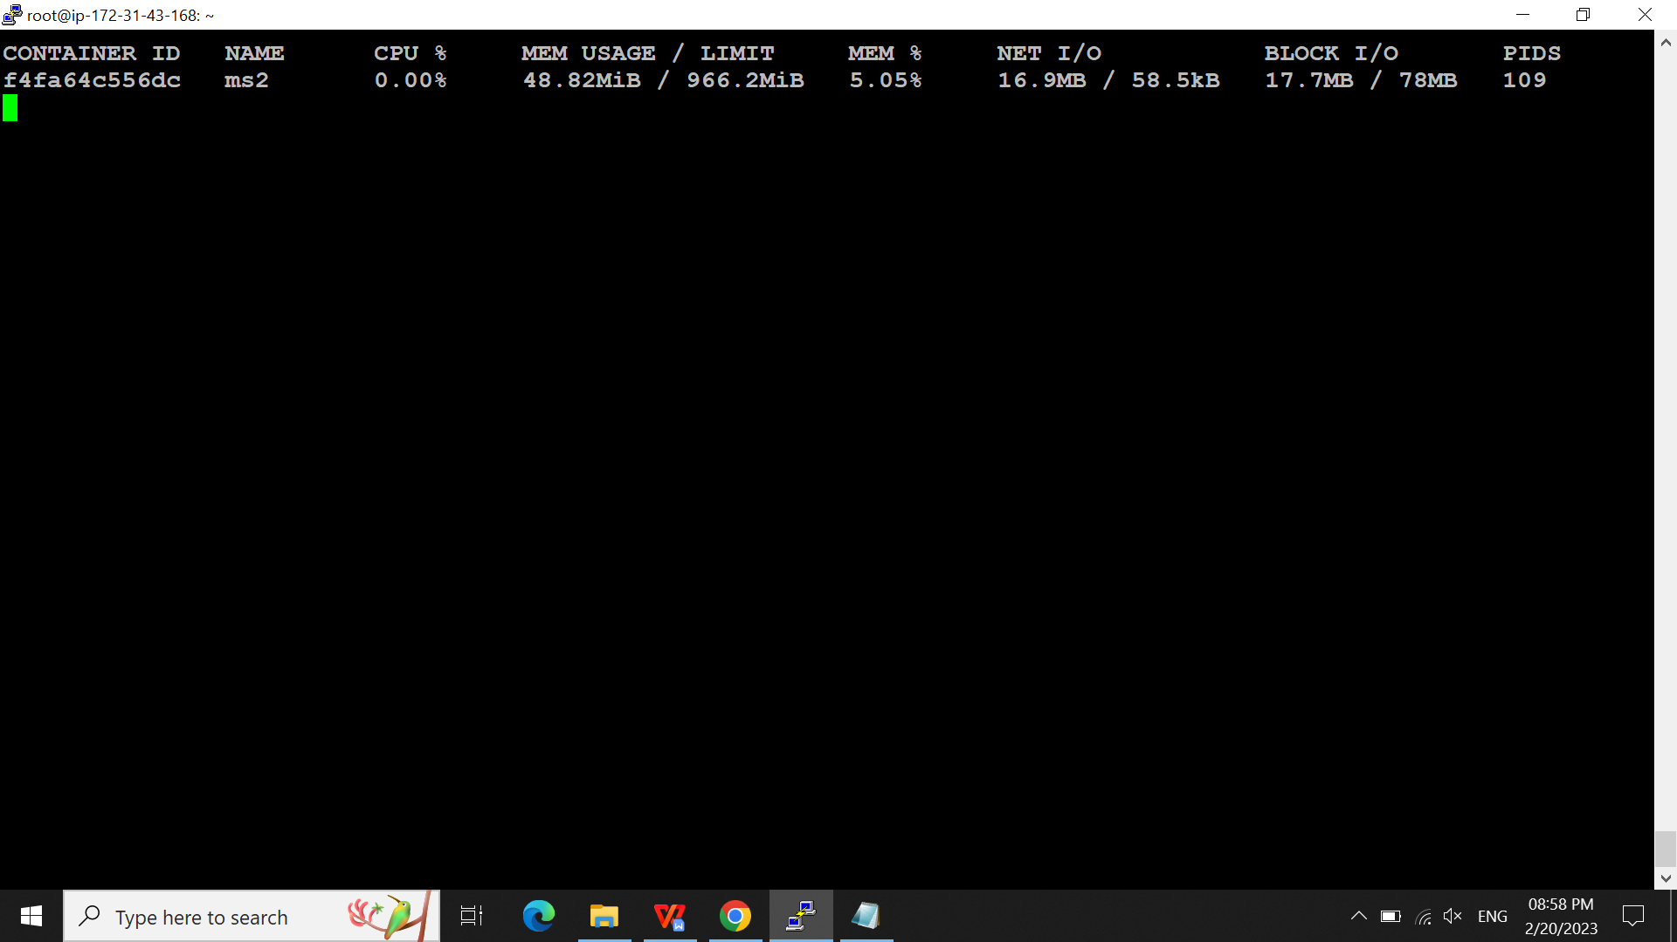

Docker logs c-id

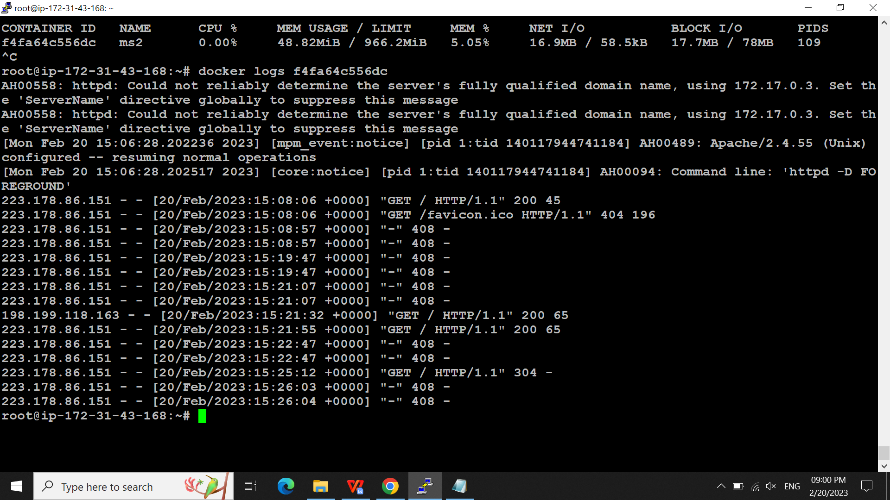

Docker inspect c-id -it show env var and what all we did in that cont

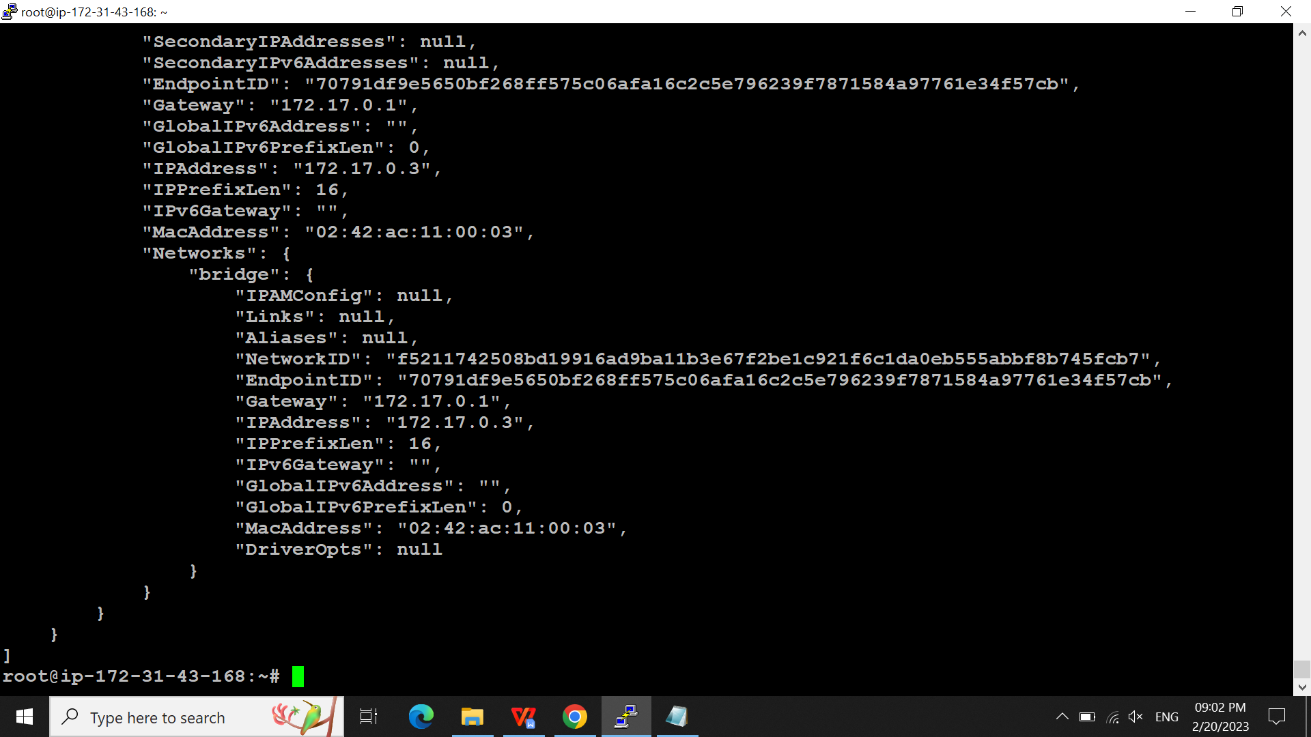

Docker info c-id ->it show info abt the cpu,mem

30 docker logs f4fa64c556dc

31 docker inspect f4fa64c556dc

32 docker info f4fa64c556dc

33 docker info --help

34 docker ps -a

35 docker rmi httpd

36 docker rm -f f4fa64c556dc

37 docker rm -f 295ca72f90d7

38 docker ps -a

39 docker prune

40 docker container prune

41docker rmi httpd

42 docker images

Docker img cloud backup: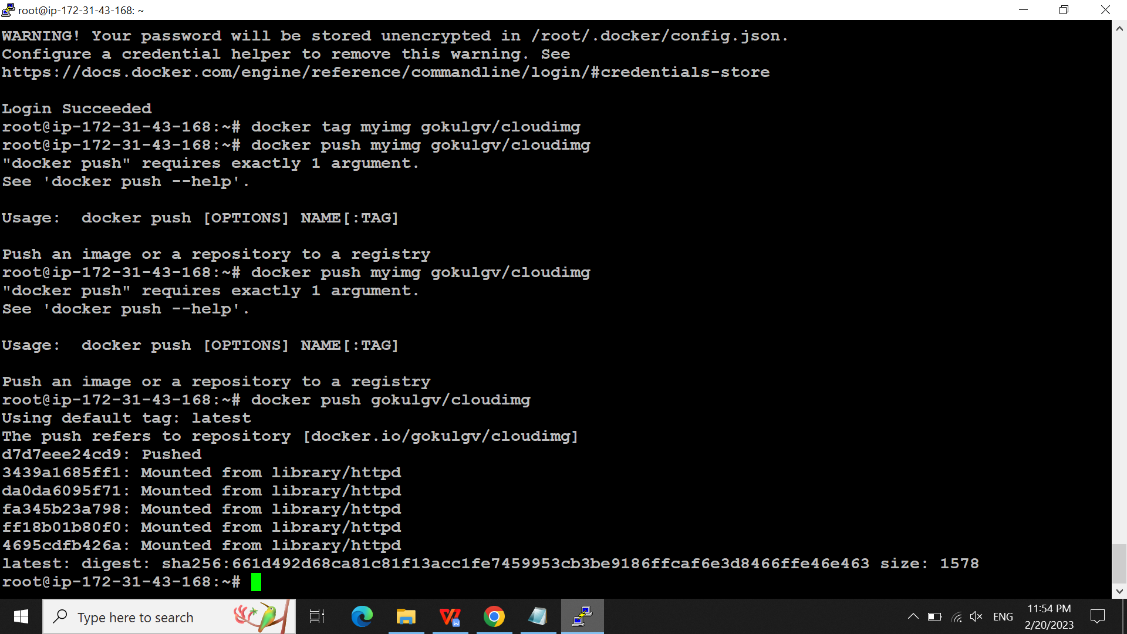

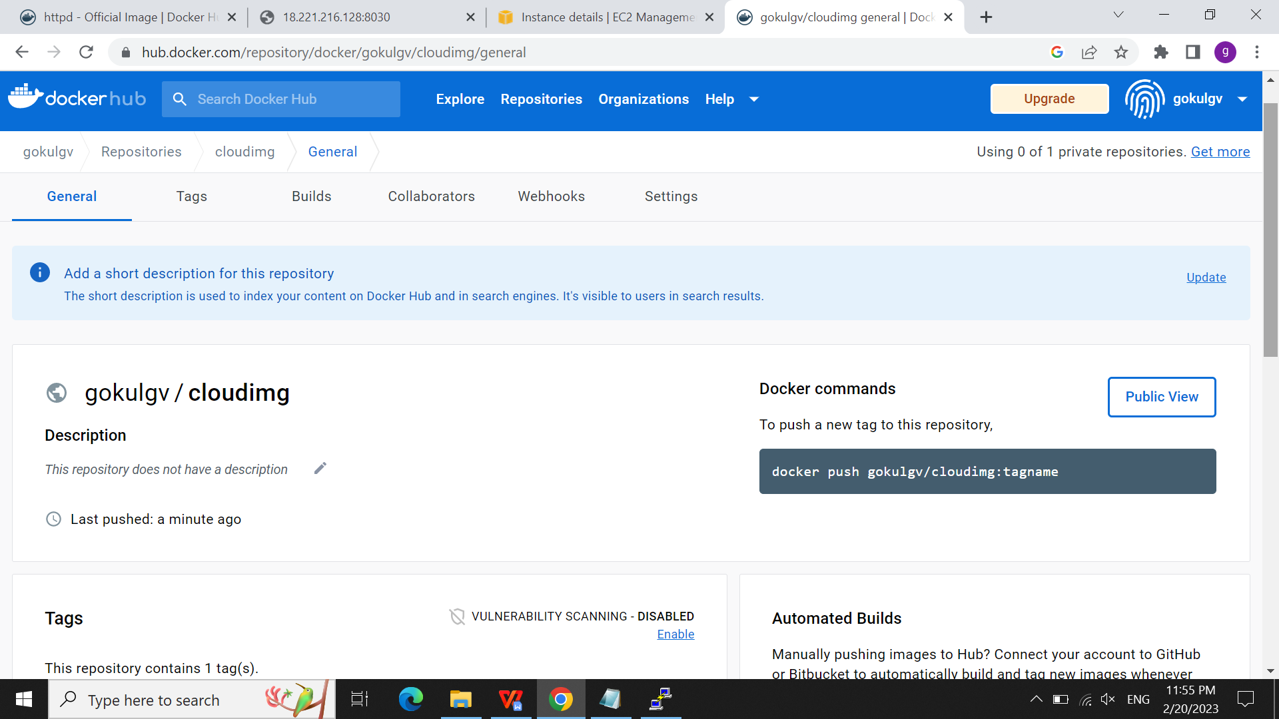

docker commit 3e084545eaec myimg

58 docker images

59 docker save -o /root/myimg.tar myimg

60 ls

61 docker rm -f 97bacce782e8

62 docker ps

63 docker rmi 97bacce782e8

64 docker load -i myimg.tar myimg

65 docker Load -i myimg.tar myimg

66 docker load -i myimg.tar myimg

67 docker load -i myimg.tar

68 docker images

69 docker login

70 docker tag myimg gokulgv/cloudimg

71 docker push myimg gokulgv/cloudimg

72 docker push gokulgv/cloudimg

73 docker logout

Writing a Docker File and executing it:

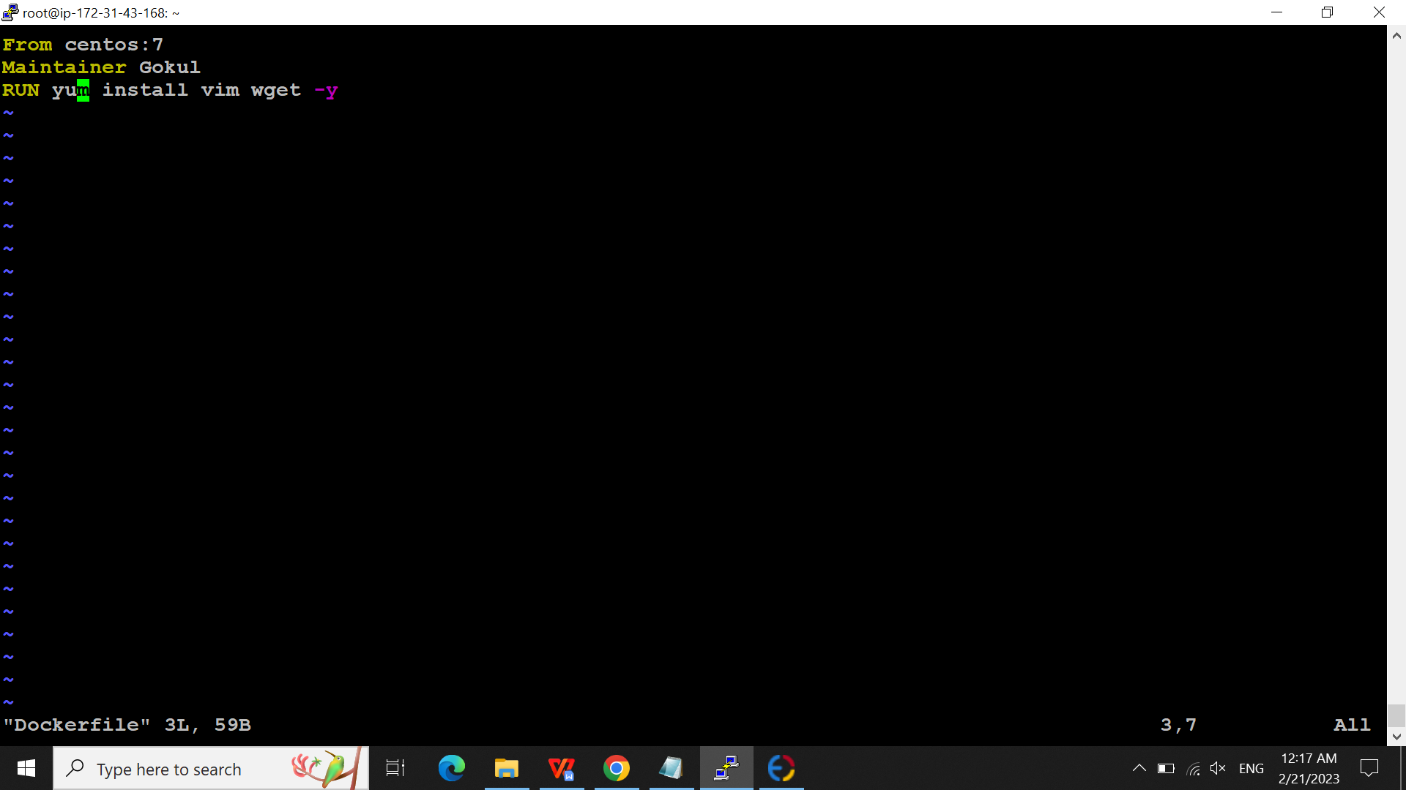

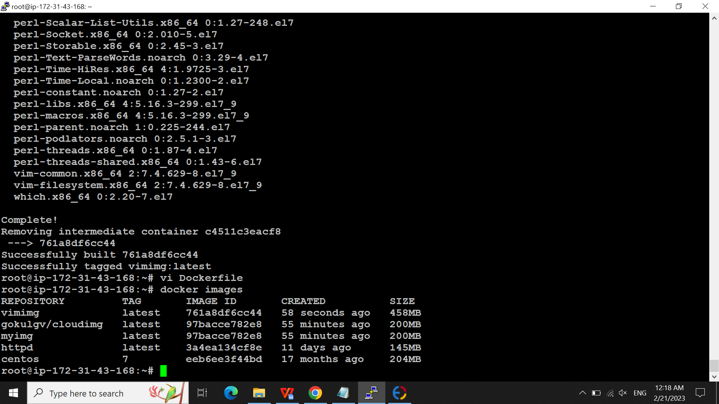

AGAIN CREATING A DOCKER FILE USING THE EXISTING DOCKER FILE IMG:

